**DevOps project creation**

1. Add “new resource” and search for DevOps starter.

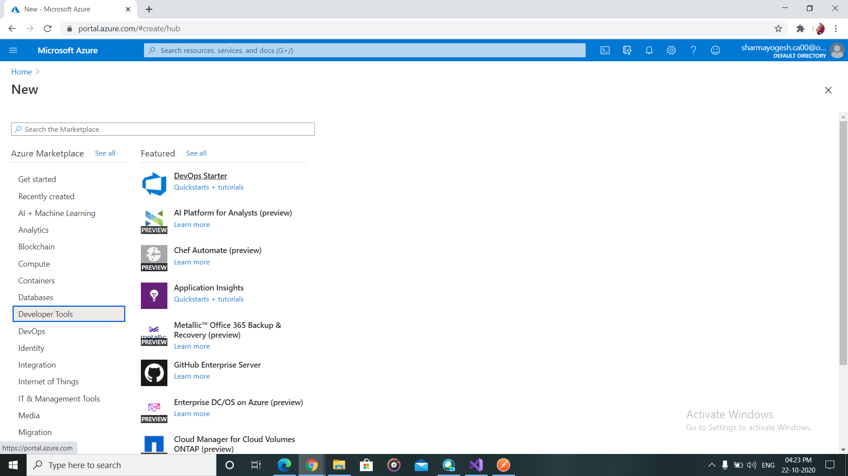

1. Select the appropriate options according to need.

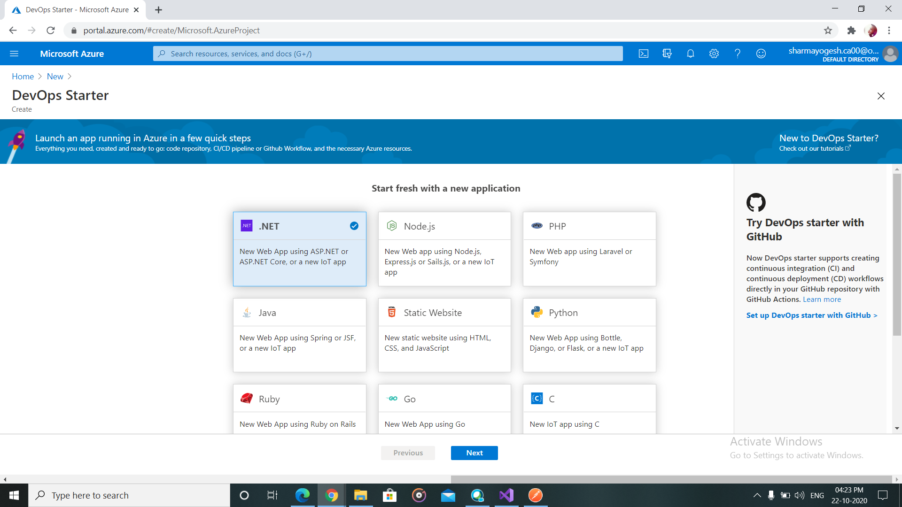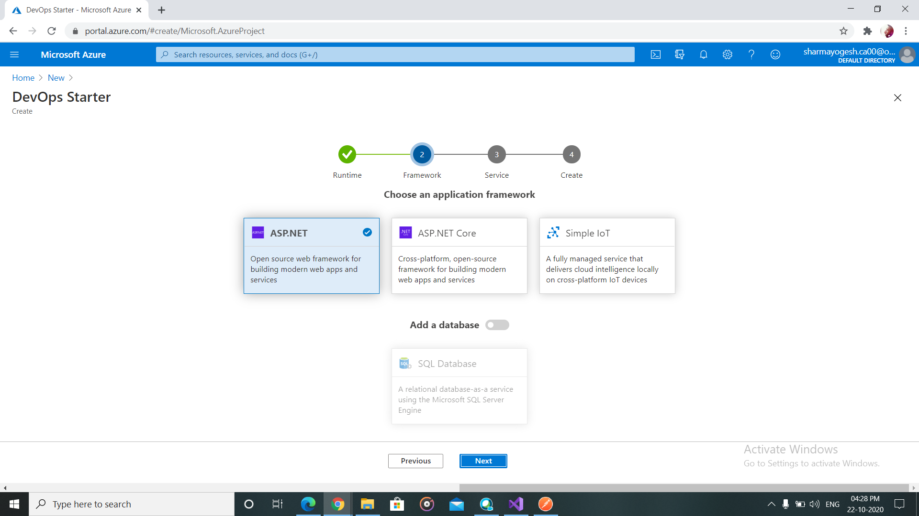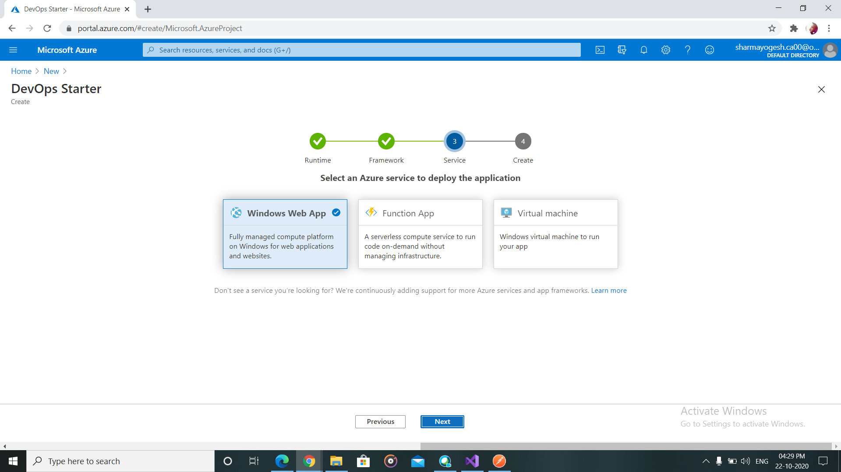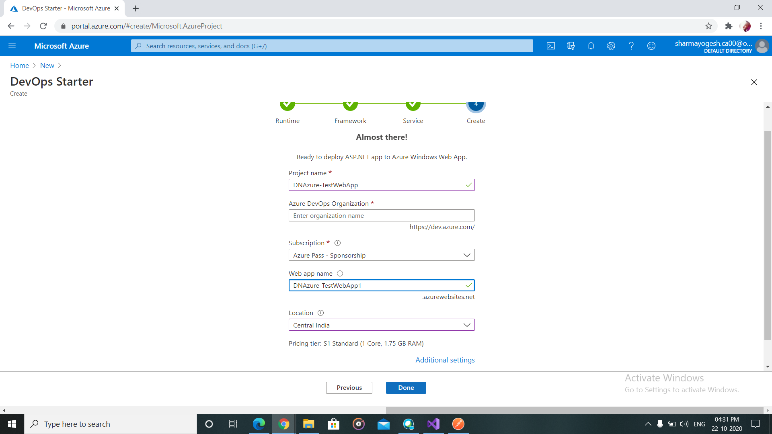

1. After clicking done, wait for deployment to be completed. And then “Go to resource”.

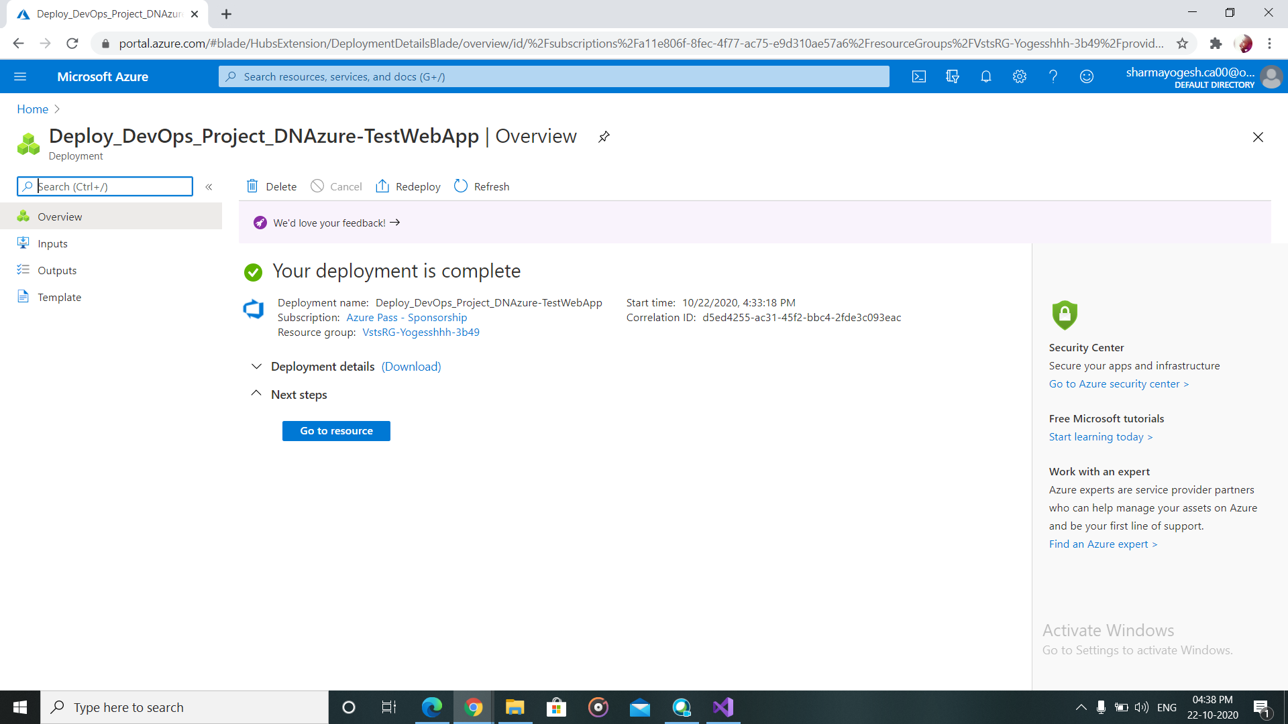

1. After the final release under “dev” is completed. Go to “browse”. It will redirect to a default website.

